**Assignment 4.3**

Lab 4: Advanced Prompt Engineering

**Course:** AI Assisted Coding

**Name:** Mohd Aadil Ashraf

**Roll NO.:** 2403A51315

**Instructor:** Dr. Mohammand Ali Shaik

**Date:** 20/08/2025

Lab 4: Advanced Prompt Engineering – Zero-shot, One-shot, and Few-shot

# Objectives

- Try different prompting methods (zero-shot, one-shot, few-shot).  
- See how output changes with examples.  
- Learn how context affects AI answers.

# Task 1 – Zero-shot

Prompt: Write a function that checks if a year is leap year.

Code (AI Output):

def is_leap_year(year):  
 if (year % 400 == 0) or (year % 4 == 0 and year % 100 != 0):  
 return True  
 else:  
 return False

Output Example:  
is_leap_year(2024) -> True  
is_leap_year(2023) -> False

# Task 2 – One-shot

Prompt: Example: 10 cm → 3.93 inches. Write a function to convert cm to inches.

Code (AI Output):

def cm_to_inches(cm):  
 return cm / 2.54

Output Example:  
cm_to_inches(10) -> 3.93

# Task 3 – Few-shot

Prompt Examples:  
- Input: "John Doe" → "Doe, John"  
- Input: "Alice Smith" → "Smith, Alice"

Code (AI Output):

def format_name(full_name):  
 first, last = full_name.split()  
 return f"{last}, {first}"

Output Example:  
format_name("John Doe") -> "Doe, John"  
format_name("Alice Smith") -> "Smith, Alice"

# Task 4 – Compare Zero-shot vs Few-shot

Zero-shot Prompt: Write a function to count vowels in string.  
Few-shot Prompt Examples:  
- "apple" → 2  
- "hello" → 2

Zero-shot Code:

def count_vowels(text):  
 vowels = "aeiou"  
 return sum(1 for c in text.lower() if c in vowels)

Few-shot Code:

def count_vowels(text):  
 vowels = "aeiou"  
 total = 0  
 for ch in text.lower():  
 if ch in vowels:  
 total += 1  
 return total

Reflection: Zero-shot worked fine, but few-shot gave more reliable logic. Examples helped shape output.

# Task 5 – Few-shot

Prompt Examples:  
- A file with 3 lines → Output 3  
- A file with 5 lines → Output 5

Code (AI Output):

def count_lines(filename):  
 with open(filename, "r") as f:  
 return len(f.readlines())

Output Example:  
count_lines("test.txt") -> 3

# Conclusion

- Zero-shot: Works but sometimes vague.  
- One-shot: Better guidance.  
- Few-shot: Most accurate and structured.  
- More examples = better results.

Screenshot:

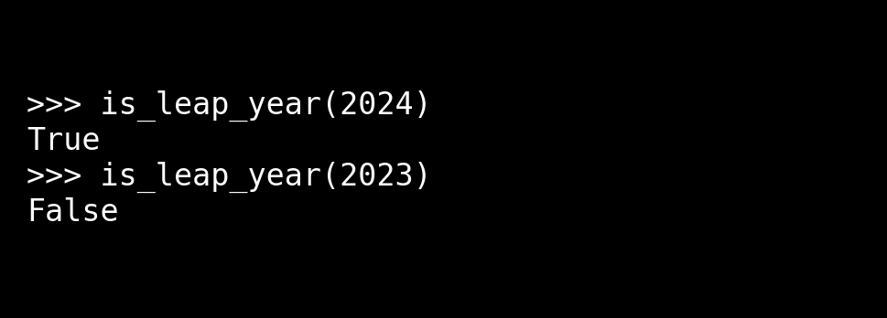

Screenshot:

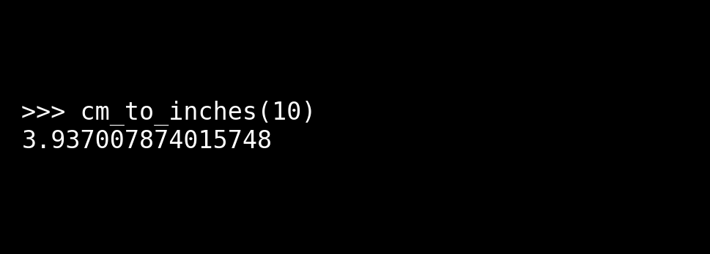

Screenshot:

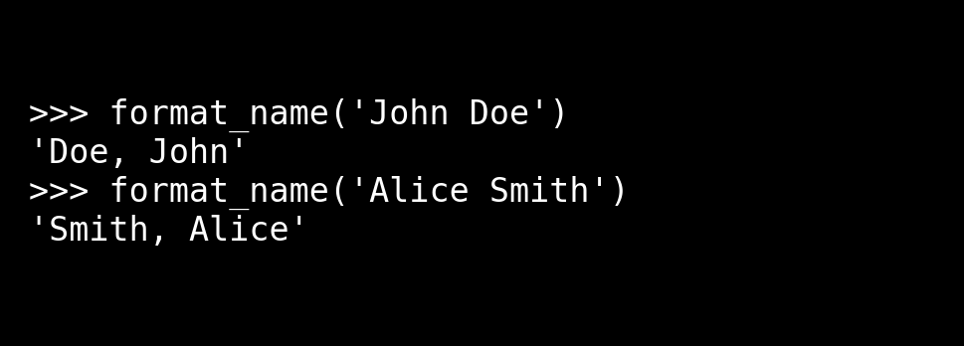

Screenshot:

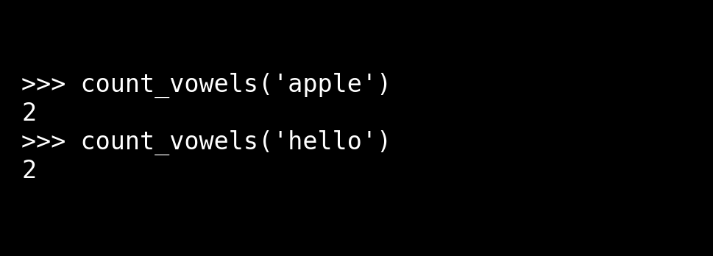

Screenshot:

